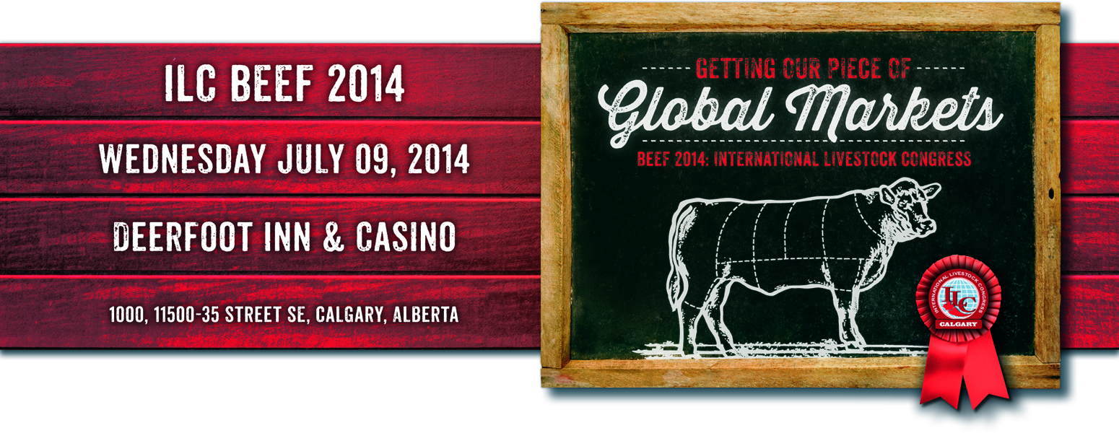**International Livestock Congress Student Program**

**Guidelines**

In an effort to enhance the educational experiences of university and college students and strengthen the leaders of tomorrow’s livestock and meat industry, the ILC awards travel bursaries each year for the International Livestock Congress to senior level undergraduates and graduate students attending accredited colleges or universities.

The International Livestock Congress Calgary, managed through the Canadian Cattlemen’s Association is a unique global event that brings leaders from the livestock and meat industry together to discuss issues of international importance that affect the future of animal agriculture. This conference is known as the International Livestock Congress Beef 2014 being held on Wednesday July 9, 2014.

Chosen winning students will participate in the **ILC Student Program** from **Tuesday July 8, 2014 to Friday July 11, 2014** inclusive in Calgary, Alberta. Events will include the International Livestock Congress Calgary, the ILC Student Forum, tours of beef related facilities north and south of Calgary including feedlots and ranches, and Grandstand tickets to the Calgary Stampede on Friday evening.

* Bursary includes required airfare, ground transportation, hotel and scheduled meals. Travel and food and beverage expenses will not be covered if not authorized by ILC.
* Scholastic achievement, leadership experiences and letters of recommendation are all part of the stringent qualifying requirements for this fellowship.
* Applications and materials will be judged by a selection committee against a set criteria, and up to 20 students will be selected to be ILC Student Program travel bursary recipients.
* Bursary recipients must participate in all activities laid out in the ILC Student Program in order to qualify for coverage of expenses, and develop a professional paper that summarizes the outcomes of the event.
* This paper must be submitted in English to the student’s department head and a copy forwarded to the ILC office within 30 days following the Congress. Papers will be evaluated by a selection committee for possible publication in the event proceedings or ILC website.
* Recipients will also be required to make a presentation to a breed association or a similar group in their area about their experiences at the International Livestock Congress.

**APPLICATION PROCESS:**

The application process will be almost entirely electronic. Please read the Application Instructions carefully! All applications and supporting materials (letters of reference, photo, and transcripts) will be directed to ILC Student Program Coordinator at event@imcievents.ca. Please ensure that your name is on every piece of correspondence that you send in. Unnamed material will be discarded.

**APPLICATION INSTRUCTIONS:**

1. Complete the application form “International Livestock Congress Student Bursary Program Travel

Application”, sign the printed copy, scan the signed copy. Email the signed copy to ([event@imcievents.ca](mailto:admin2@irismeck.com)). Please include “ILC Calgary – (and your name)” in the subject line and submit your application.

1. Three letters of reference must be submitted via email as attachments to event@imcievents.ca. All letters of reference must be received directly from the person providing the reference (not from the student applicant, and must include reference name and all contact info including full name, title, company or association, address, email, phone, fax, and must state the name of the applicant the letter is for). Please ensure that the email subject line and letter clearly reads “ILC Calgary – and the student program name”.
2. One head and shoulders photograph must be submitted via email as attachments to event@imcievents.com. Photos must be high quality, suitable for publishing in the program, and sent as a jpg, png or tif file at least 250K in size and in **color**. NO PASSPORT PHOTOS.
3. Please provide a college transcript for each degree or diploma that you have received and/or are currently pursuing. College transcripts can be scanned and emailed to events@imcievents.ca or faxed to 403-255-4592.
4. Once your application is received, an email will be sent to your Department Head asking them to approve your submitted application. Please notify your Department Head that you are applying for this bursary and make them aware that they will need to approve your application via email response. If you would like to speed up the entry system, please have your Department Head send in a letter of approval with your application form. Please ensure that you have provided us your Department Head name in full, and all their contact information including phone, fax, email, and mailing address complete with postal and zip codes.

Deadline for applications and all supporting materials: **May 1, 2014** (All required materials must be received by the ILC office in Calgary by this date).

Please note that students have been disqualified for failing to send all required information. You will not be notified if all information is not received.

Questions regarding the application process? Contact us by email at [event@imcievents.ca](mailto:admin2@irismeck.com) or call 403-686-8407.

**Checklist for 2014 International Livestock Congress Calgary**

**Student Bursary Program Application**

􀀀 Completed application

􀀀 Completed and “Signed” application

􀀀 College transcripts

􀀀 Department head letter with all contact information

􀀀 Three (3) letters of reference with all contact information

􀀀 Head and shoulders photograph – high quality, color